21 august, 2026
Today’s topic-
Data migration tools-
- Data import wizard
- Data export wizard
- Data louder
- Workbench
Data import wizard-
On standard object- account, contacts, solutions, leads
Operation- insert, update, upsert
Limit- 50k

Data loader- external cloud, that we connect with our org
- Data Loader is an external/cloud tool that we connect with our Salesforce org.
- Go to Setup → Data Loader.
- Open Downloads and User Guide in two tabs.
Step 1: Go to Setup and search for Data Loader.
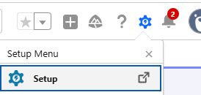
Search in quick Find Box
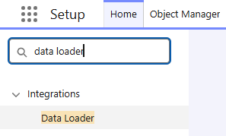

Step 2: Open Data Loader → Downloads and User Guide.
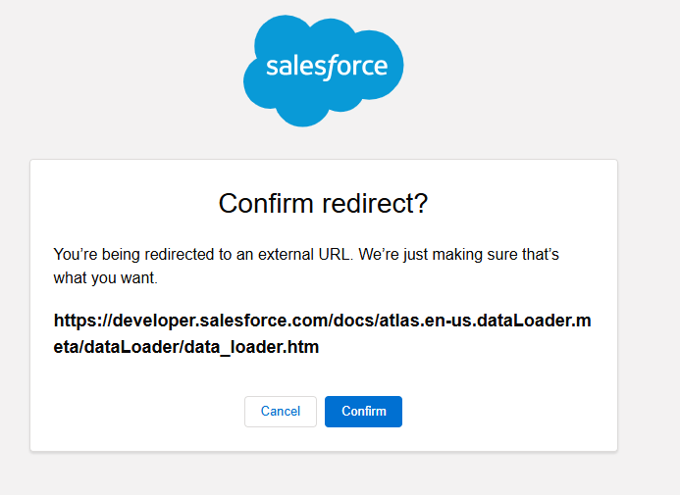
Step 3: Click Confirm to proceed with the download.
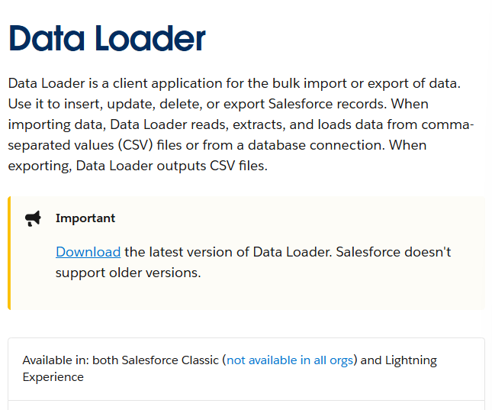
Step 4: “Download” the files of data loader.

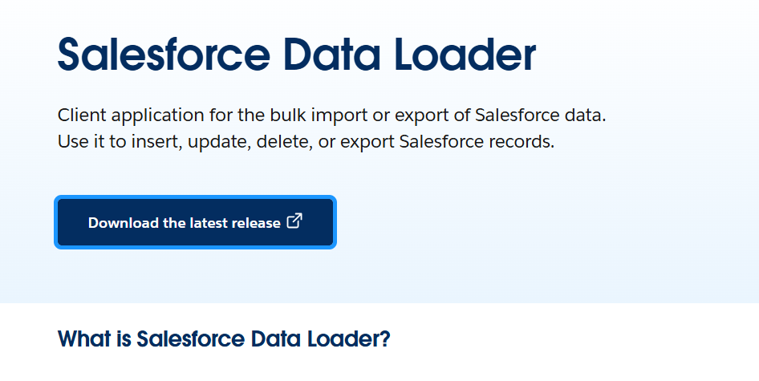
Step 5: Open the Salesforce Data Loader download page.
Click Azul and download the JRE according to your Windows version.
Java Version 21 was mentioned.
Download the .msi file.
First install JRE → Next → Next → Install.
Then extract the Data Loader ZIP folder.
Double-click on Install.
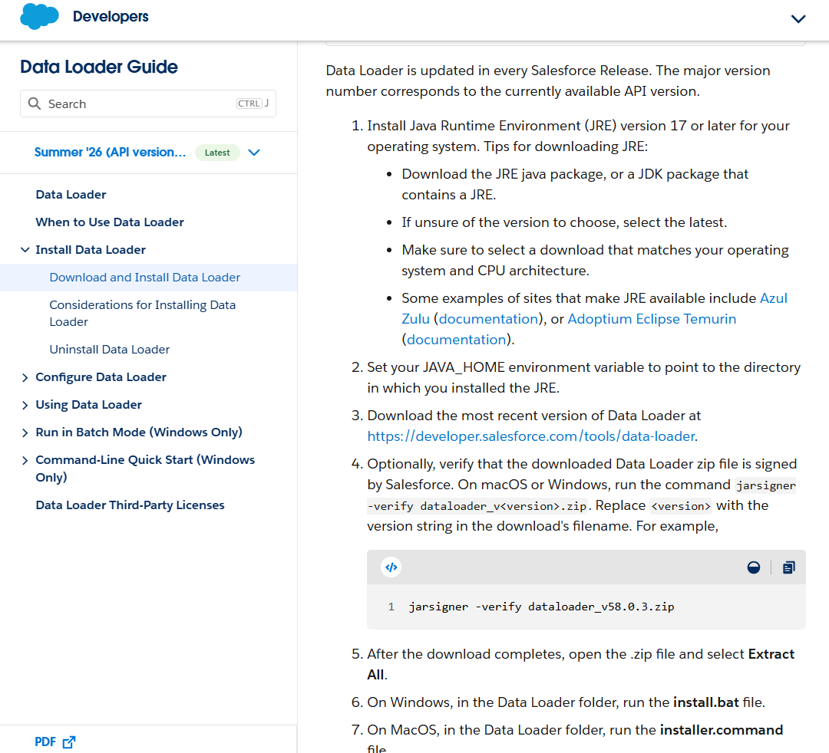
Step 6: Version 21 of java
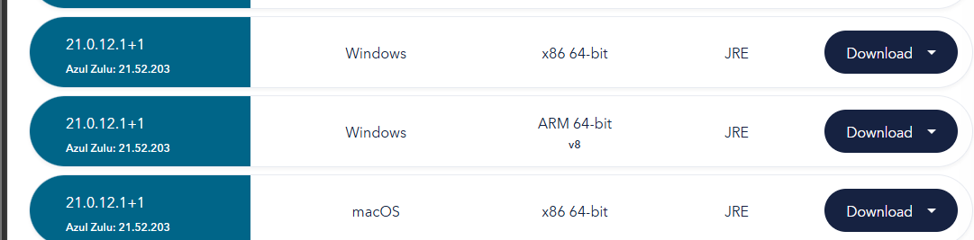
Step 7
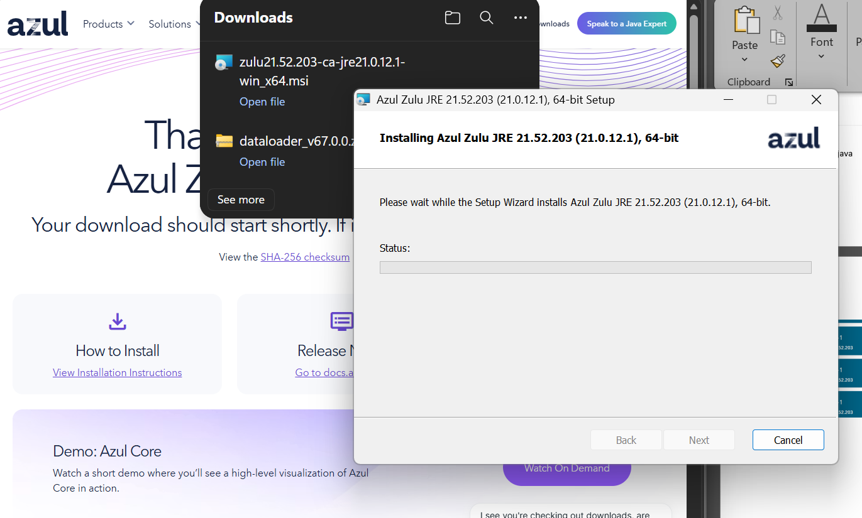
Step 8: Then extract the data loader folder zip
Double click on “install”
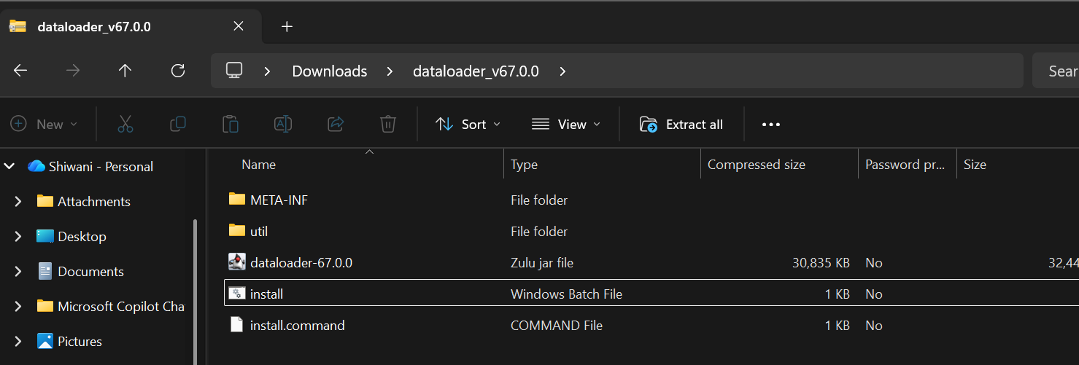
Step 9
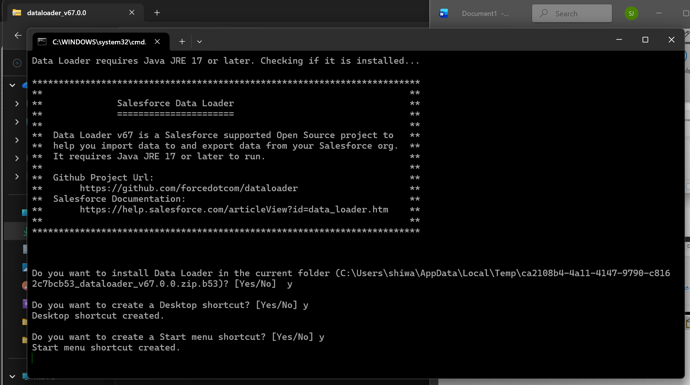
Step 10
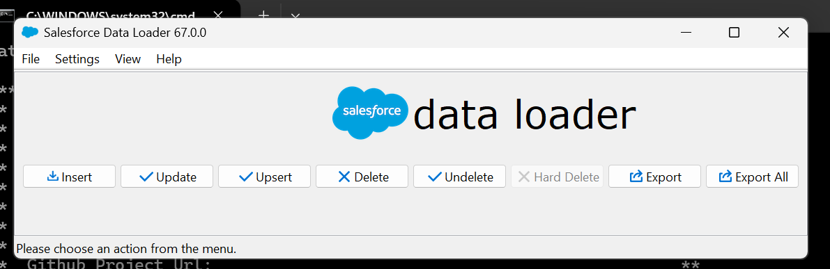
Data Loader Limit / User Story
- Limit: 5 lakh (500,000) data processing.
- User story: Insert 5 Applicant records using Data Loader.
Mapping
- Create and Edit Map
- Save Map
- Later, the same saved map can be reused — “Aage ussi ko use krlo.”
Upsert
- Upsert operation was discussed.
Bulk API
- Go to Settings → Use Bulk API.

1)Insert the data
Step 1: Open Data Loader after installation.
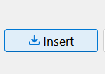
Step 2: Select the Insert operation.
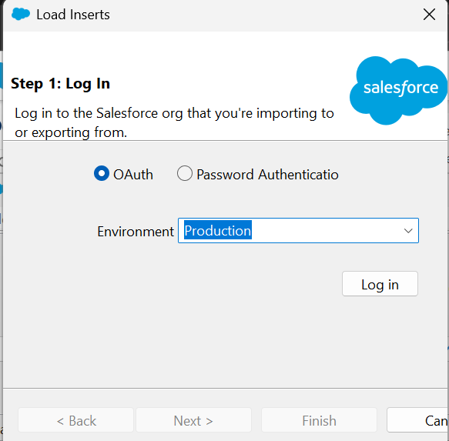
Log in via OAuth
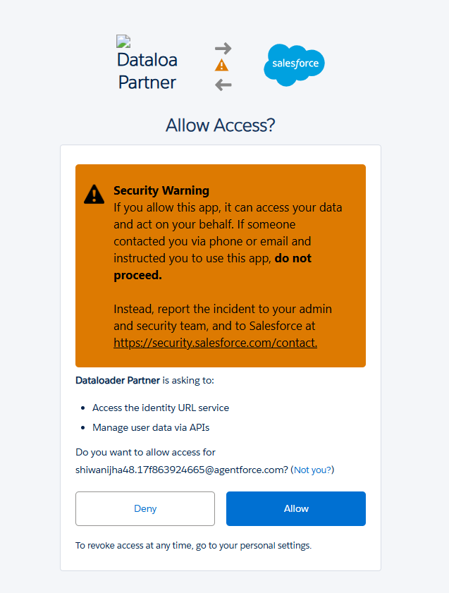

Step 3: Select the required Salesforce object, e.g. Applicant.
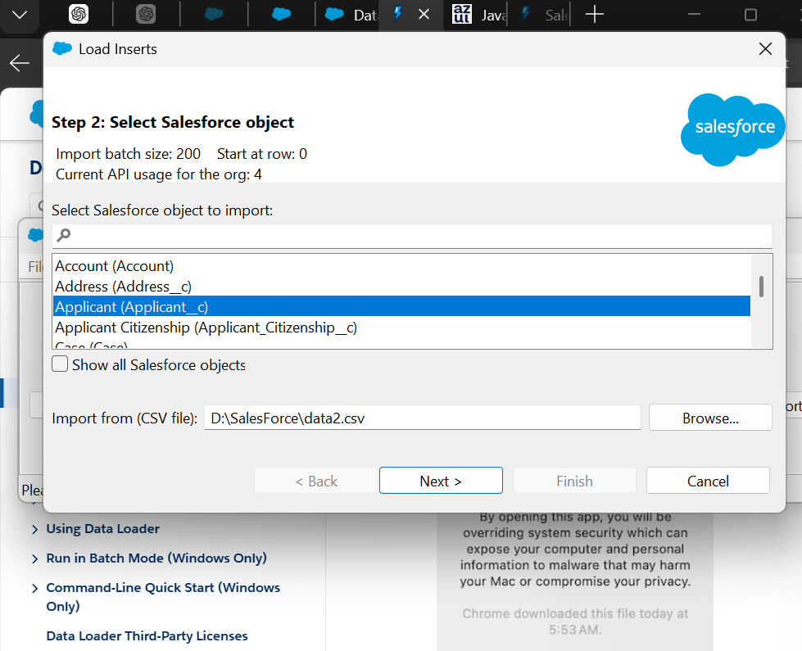
Step 4: Select the CSV/Excel file containing the records.
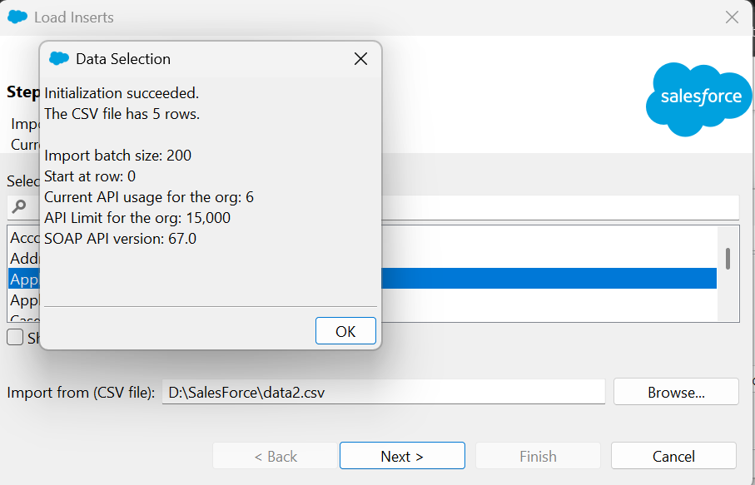
Step 5: Review the selected file and object.
Map CSV fields with Salesforce fields.
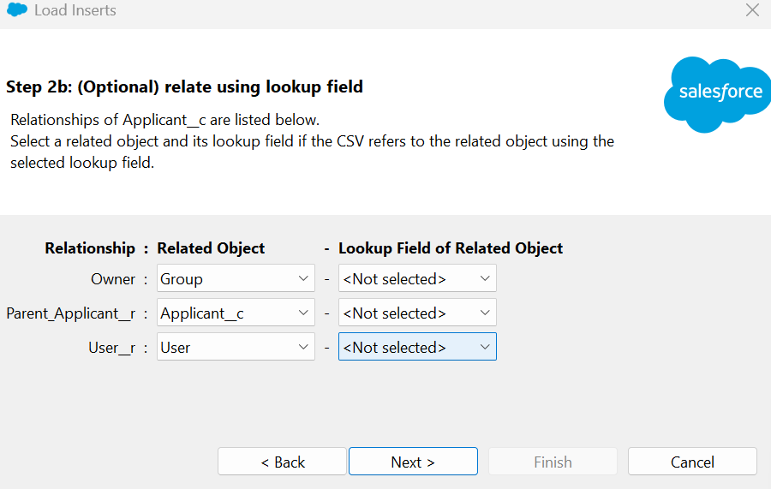
Step 6: Create/edit the required field mapping.
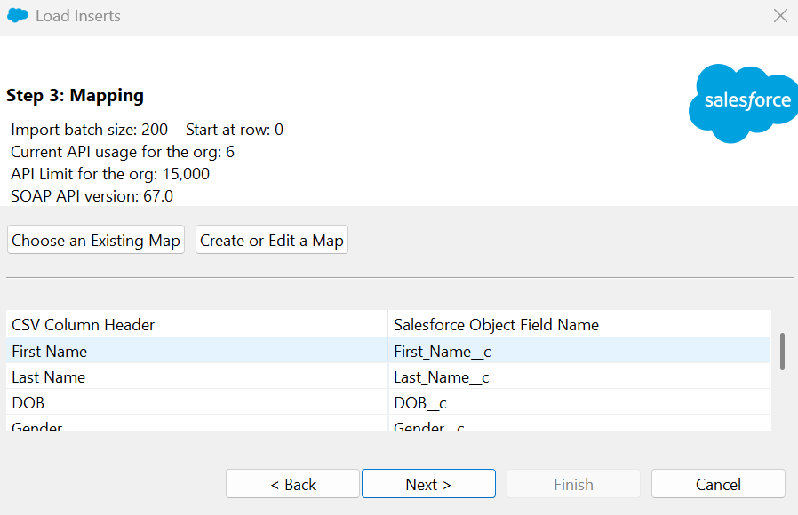
Create and edit map
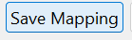
Save the mapping.
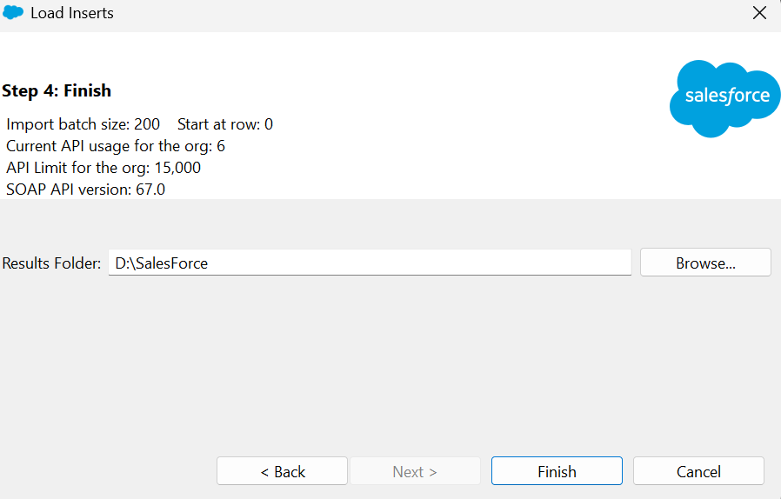
Now youll get the excel sheet of success and errors.
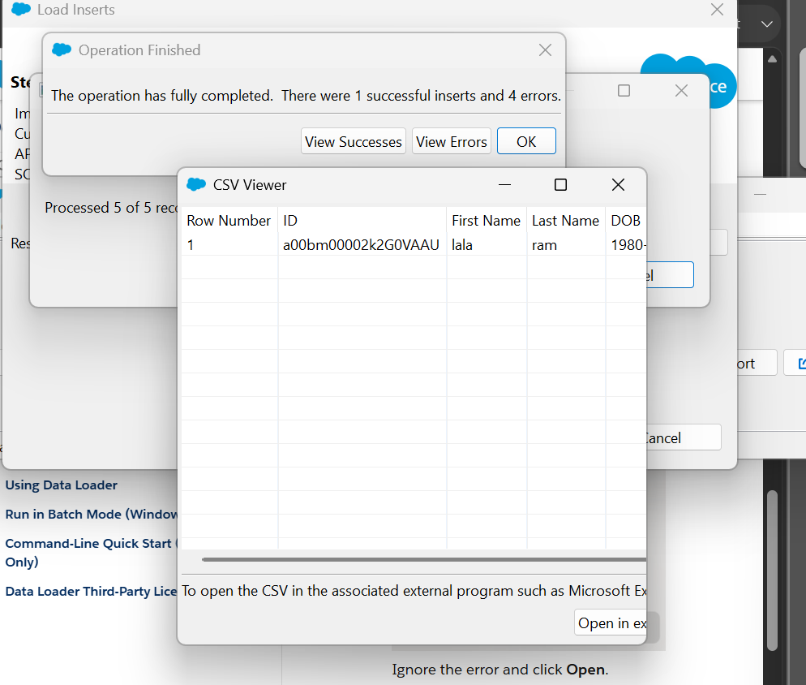
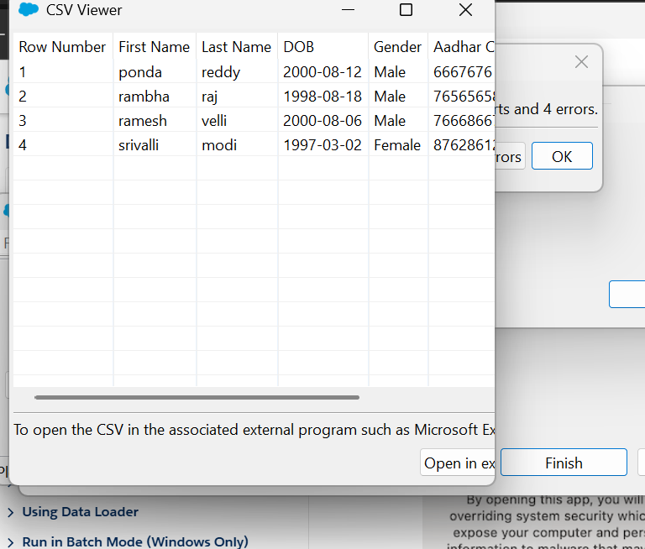

CSV file of all success data.
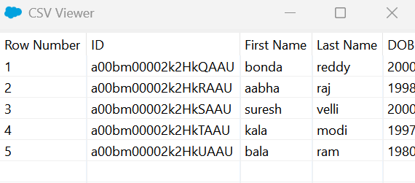

2)Upsert Operation
Step 1: Select the Upsert operation in Data Loader.
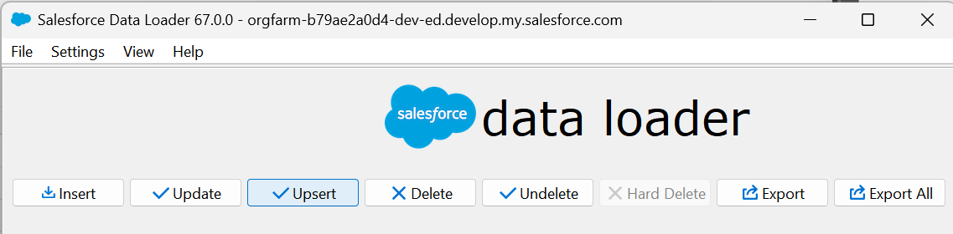
Step 2: Select the Salesforce object for the Upsert operation.
Select the CSV file containing the data.
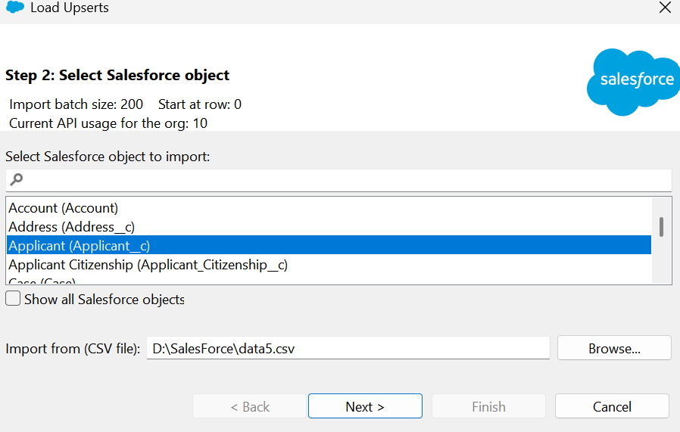
Step 3: Map the CSV fields with Salesforce fields.
Select the field used to match existing records. Review the Upsert mapping. Execute the Upsert operation.
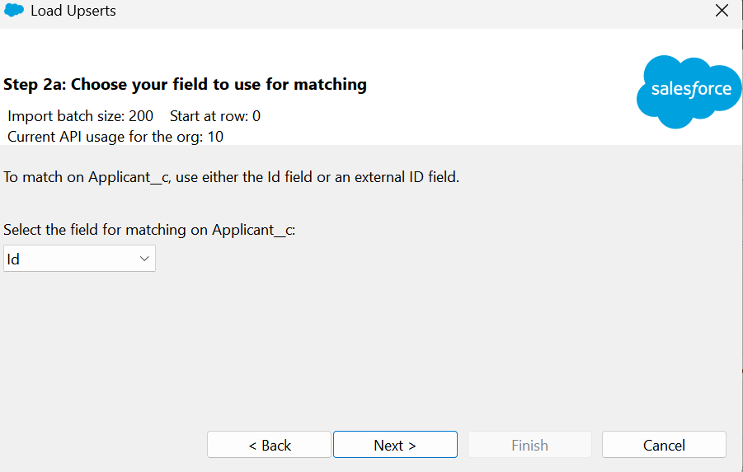
Result - Verify the success/error results.
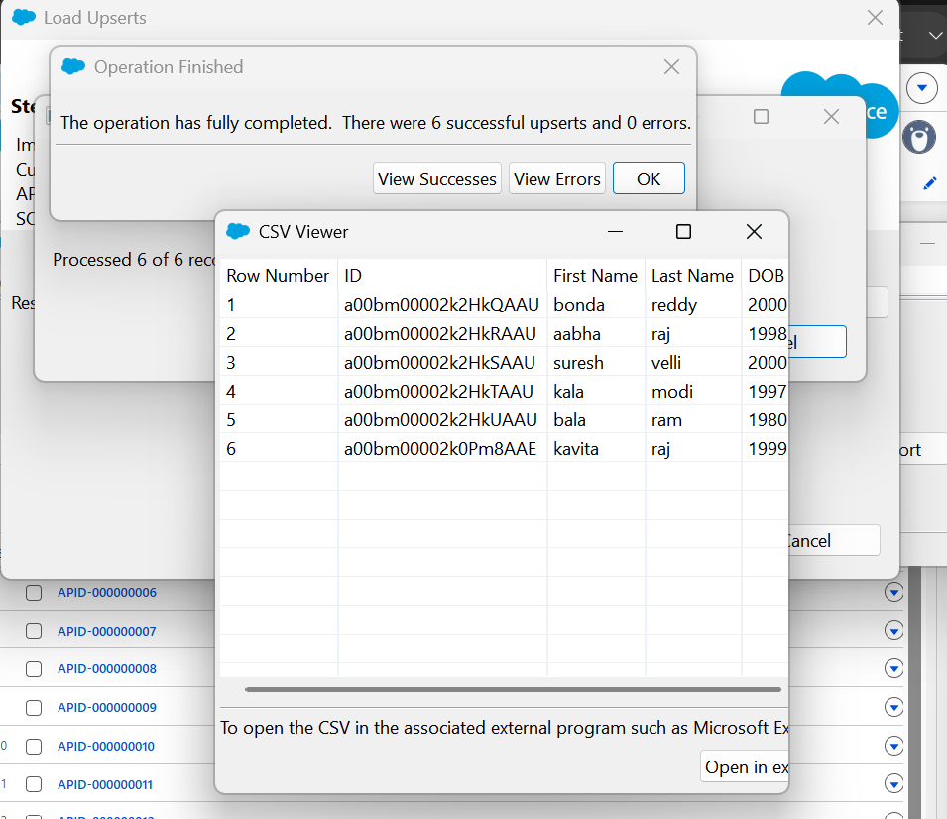

Enable Bulk API
Open Data Loader → Settings.
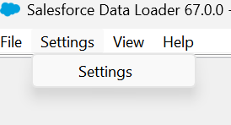
Open the Data Loader Settings window.
Enable Use Bulk API. Save/apply the Data Loader settings.
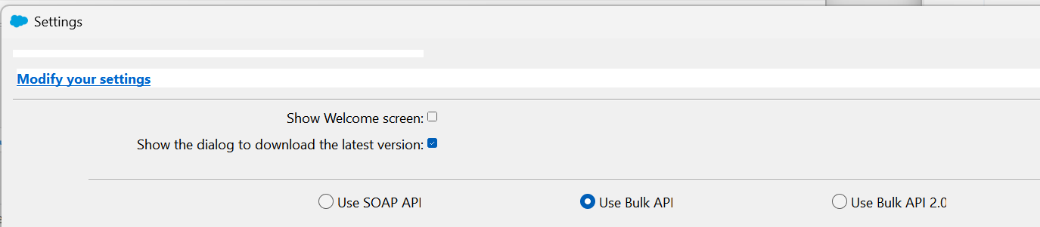
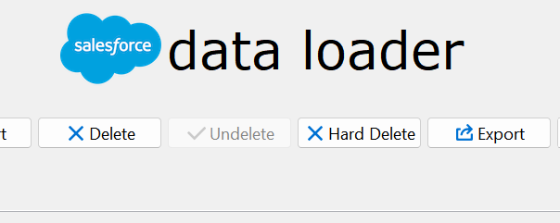

Delete / Export Operations
- Hard Delete → Permanent delete.
- Delete → Record is saved in the Recycle Bin.
- Export → Takes/exports data from the object.
- Export All → Exports data from both the object and Recycle Bin.
- Undelete → Restores data from the Recycle Bin.

3)Hard Delete
Step 1: Select Hard Delete in Data Loader.


Export can be used to find the IDs of records with Gender = Male, and then the Delete operation can be performed.
Step 1.1: Select Export to retrieve Applicant record IDs.
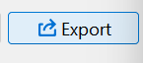
Step 2: Select the Applicant object.
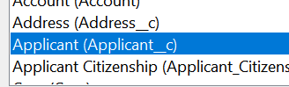
Step 3: Choose the fields required for export.
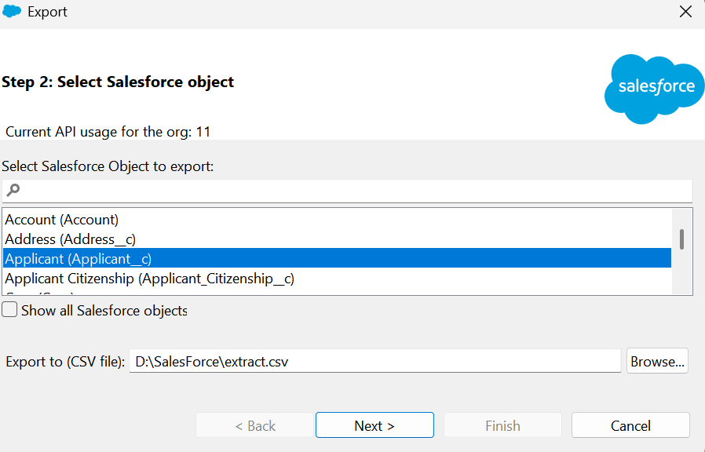
Step 4: Export the Applicant records.
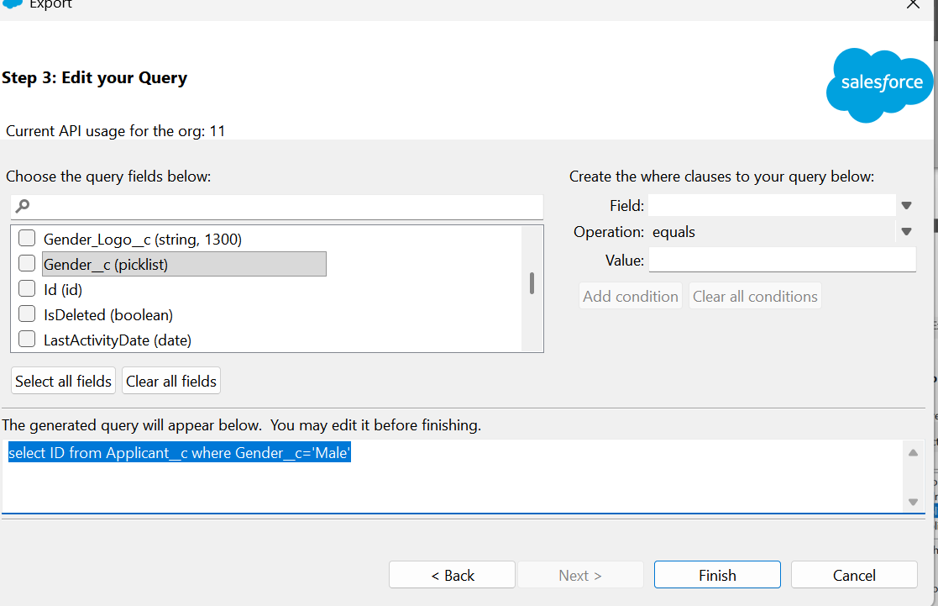
Step 5: Use the exported data to identify records with Gender = Male.
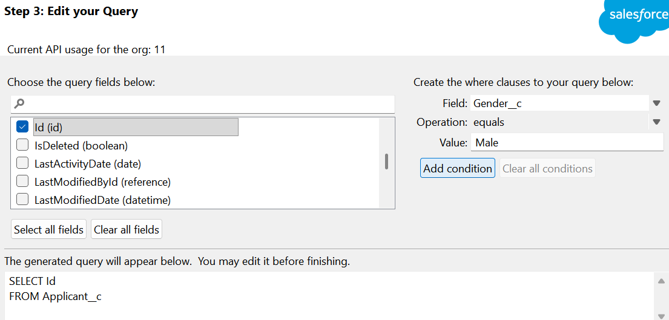
Prepare the IDs of the records to be deleted.
SOQL Query
To find Applicant records where Gender is Male:
SELECT Id
FROM Applicant__c
WHERE Gender__c = 'Male'
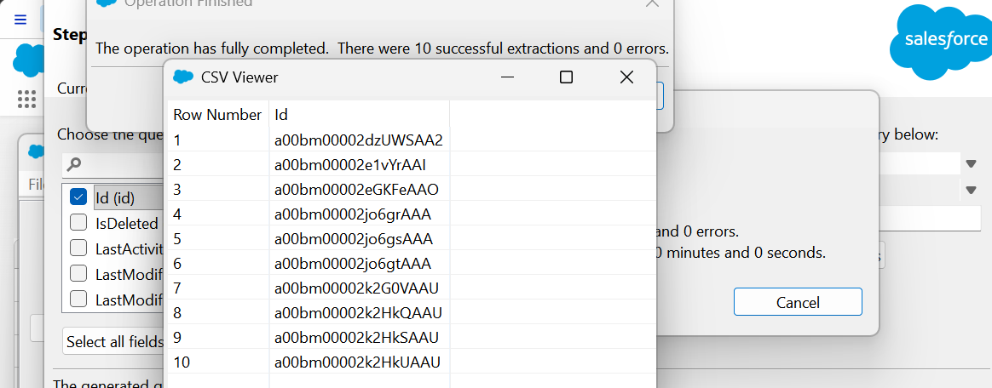

4)Delete
Step 1: select the Delete from data loader
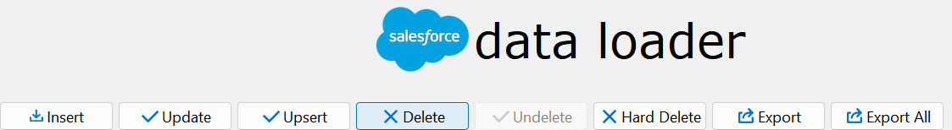
Step 2: Upload csv file and select the object
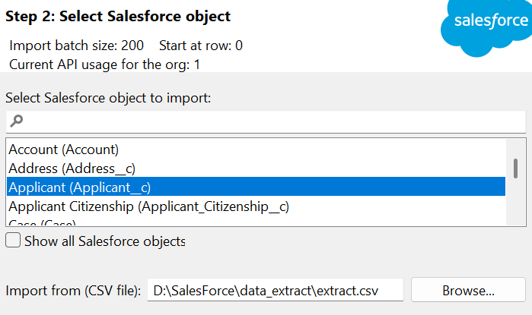
Step 3: mapping check
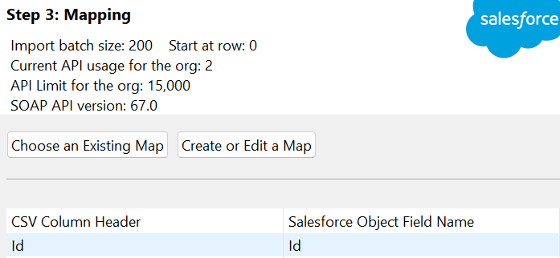
Step 4: finish it
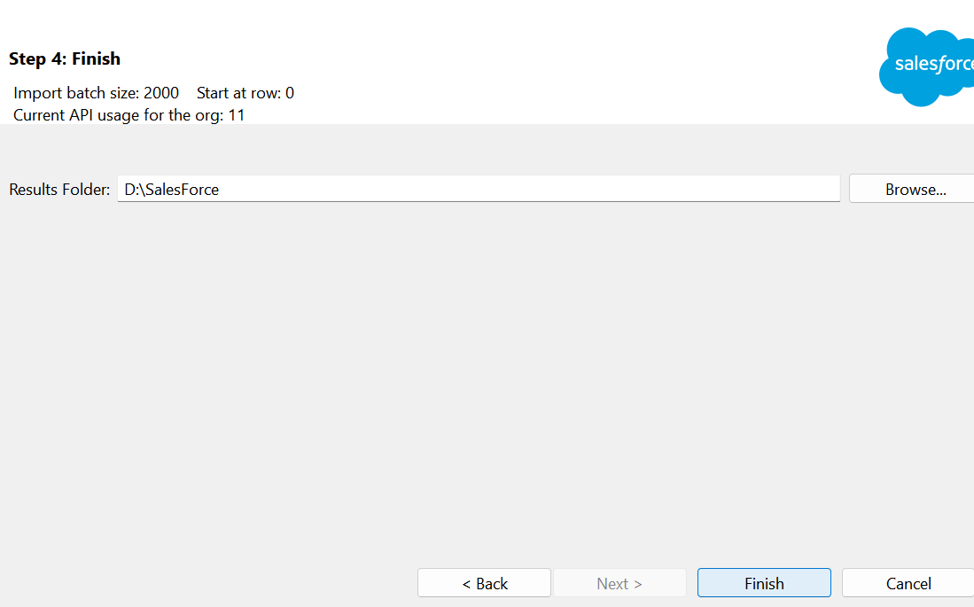
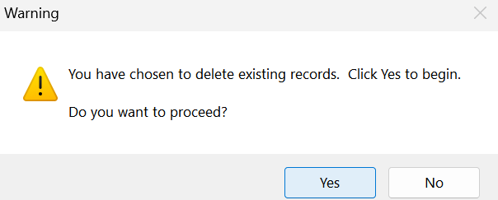
Done
5) Undelete
Step 1: select the undelete.
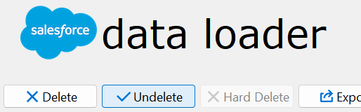
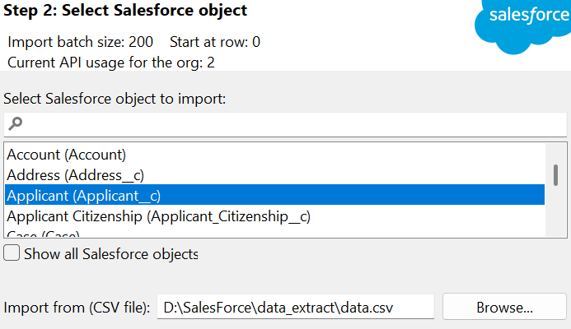
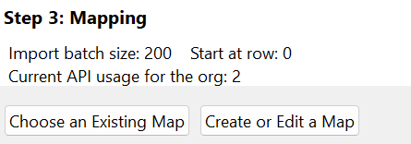
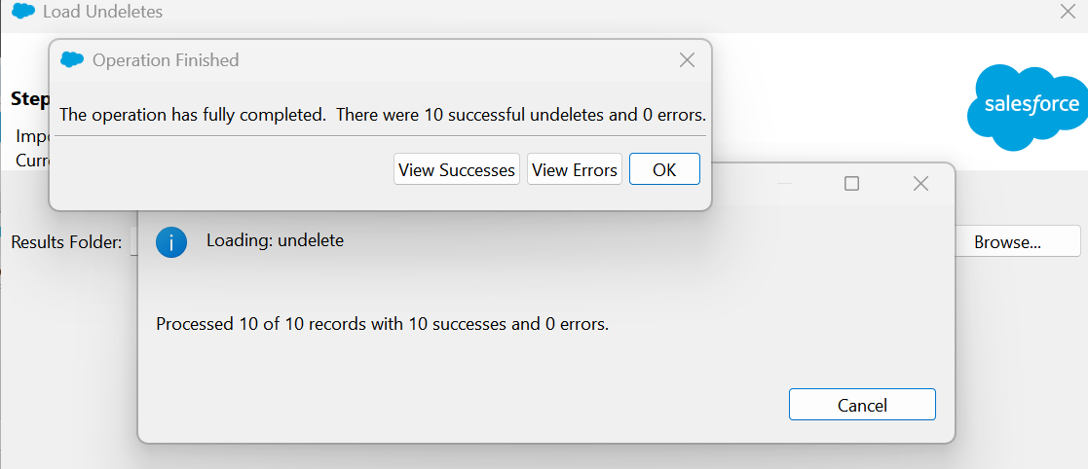

6) Hard delete-
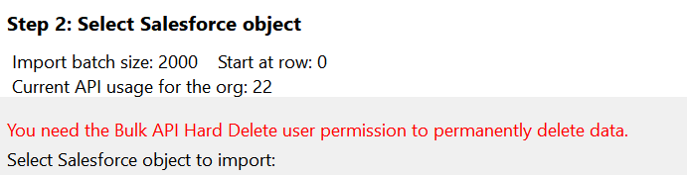
The red line means:
You need the Bulk API Hard Delete user permission to permanently delete data.
In simple words:
- You are trying to use Hard Delete.
- Hard Delete permanently removes records; they cannot be recovered from the Recycle Bin.
- Your Salesforce user must have the “Bulk API Hard Delete” permission.
- If you don't have this permission, you cannot perform Hard Delete.
Step 1: Click on Settings
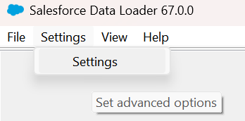
Step 2: Enable Bulk API
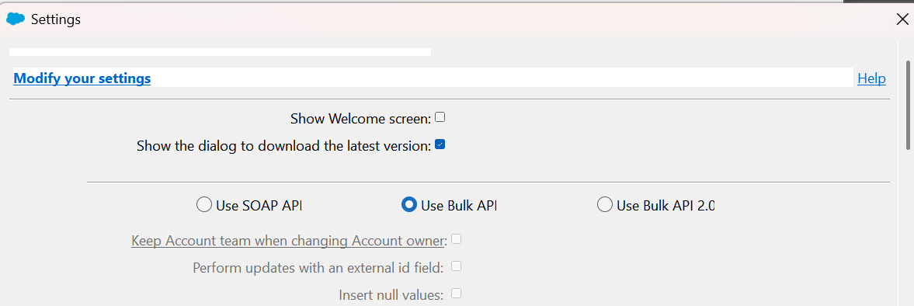
Now, hard delete is enabled.
Step 1
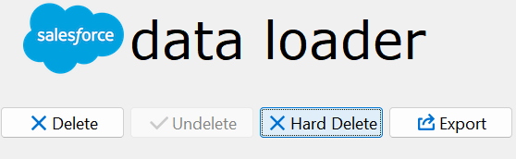
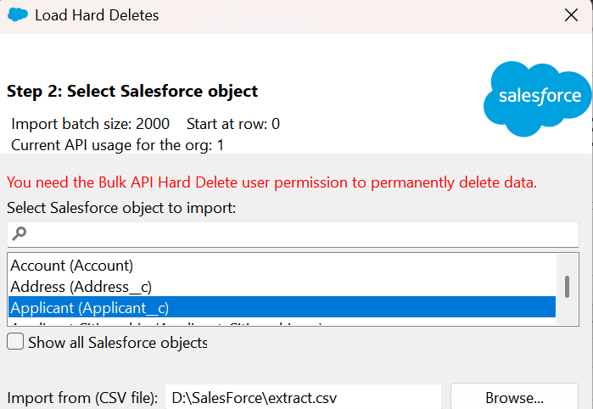
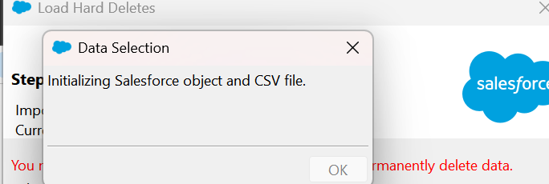
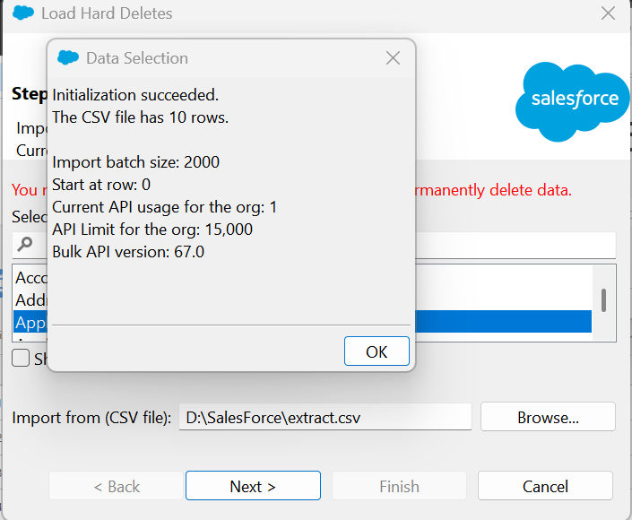
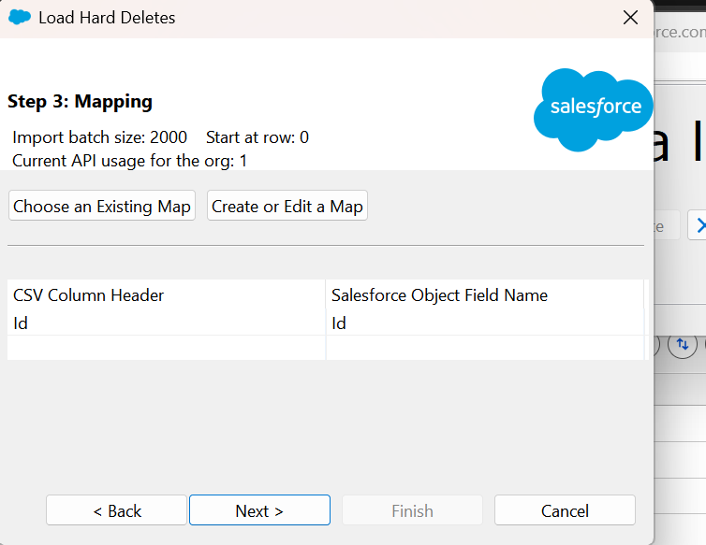
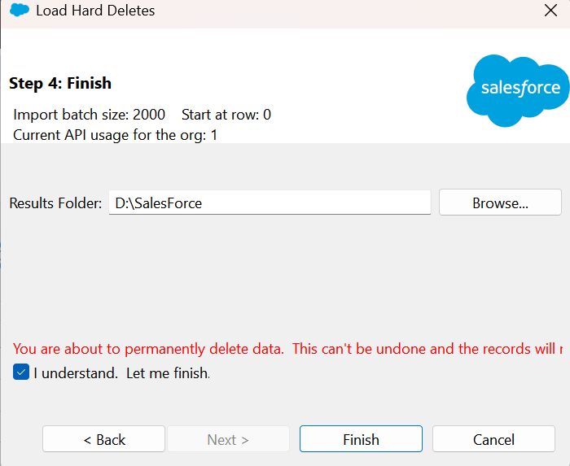
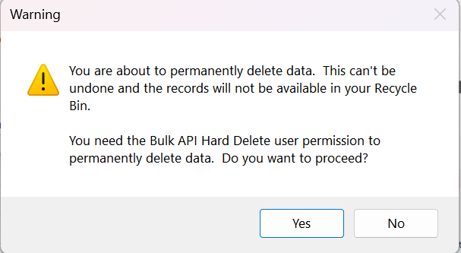
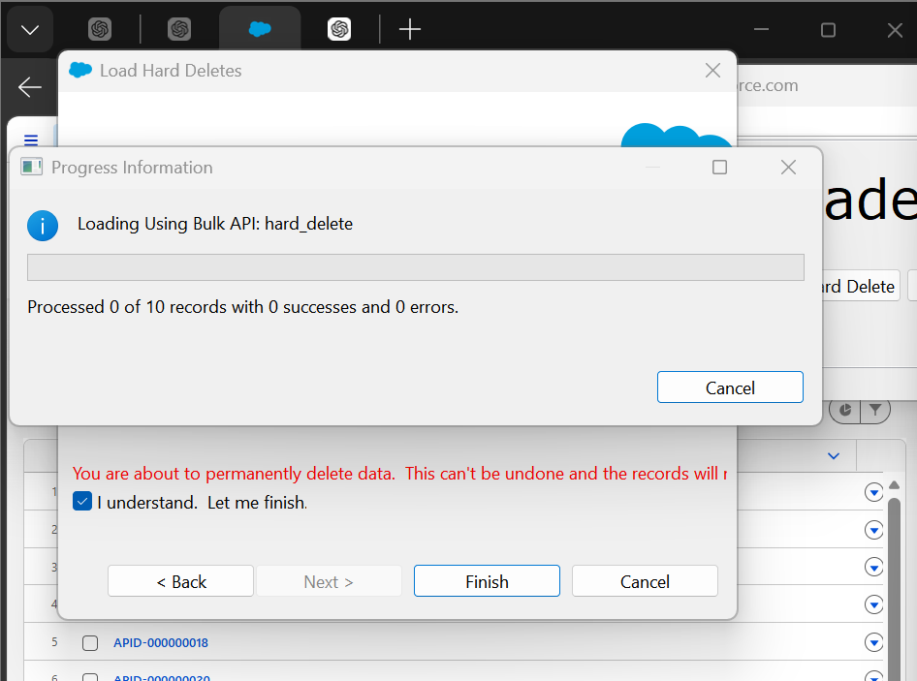
ERROR-
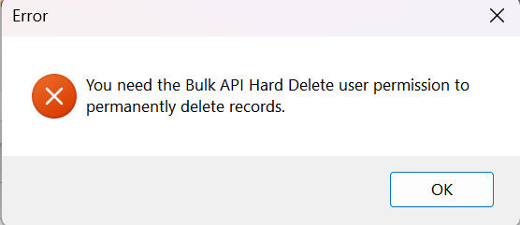

Solution-
Step 1 — Create Permission Set
Go to: Setup → Permission Sets → New Permission Set
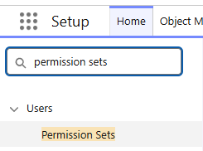
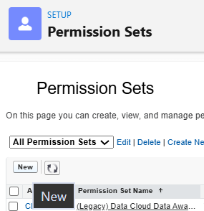
Give it a name, for example:
Bulk API Hard Delete Click Save.
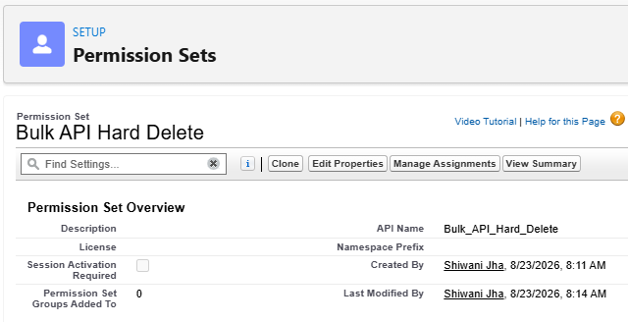
Step 2 — Enable the permission
Open the Permission Set.
Go to: System Permissions → Edit
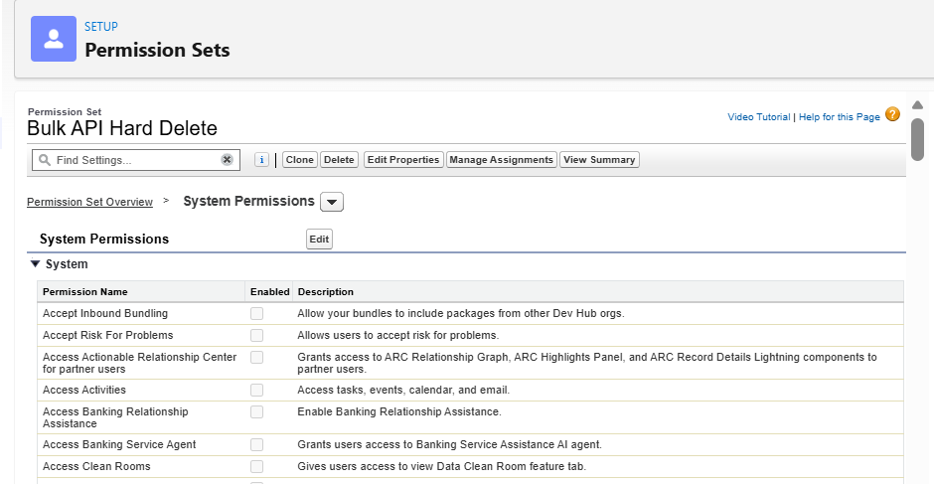
Find: Bulk API Hard Delete Check it.
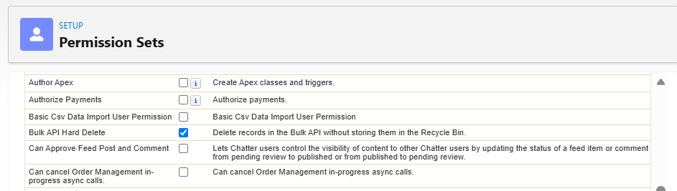
Then click Save.
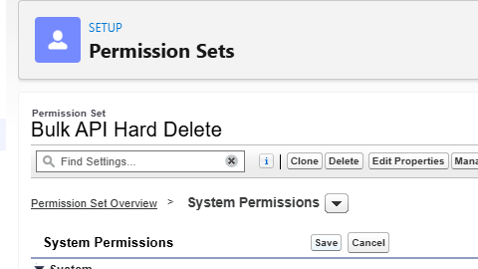

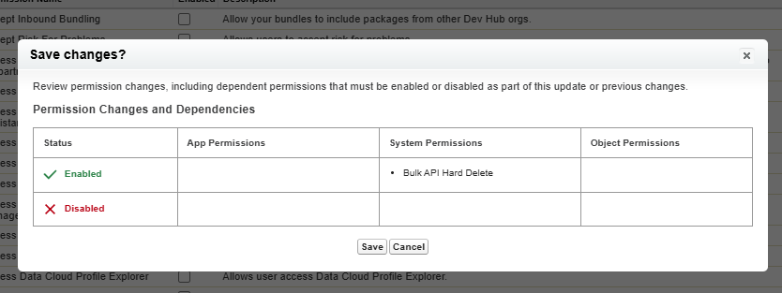
Manage assignment, click on it.
Step 3 — Assign it to your user
Inside the Permission Set: Manage Assignments → Add Assignments
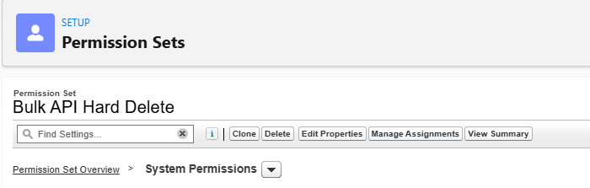
Select your Salesforce user → Next → Assign.
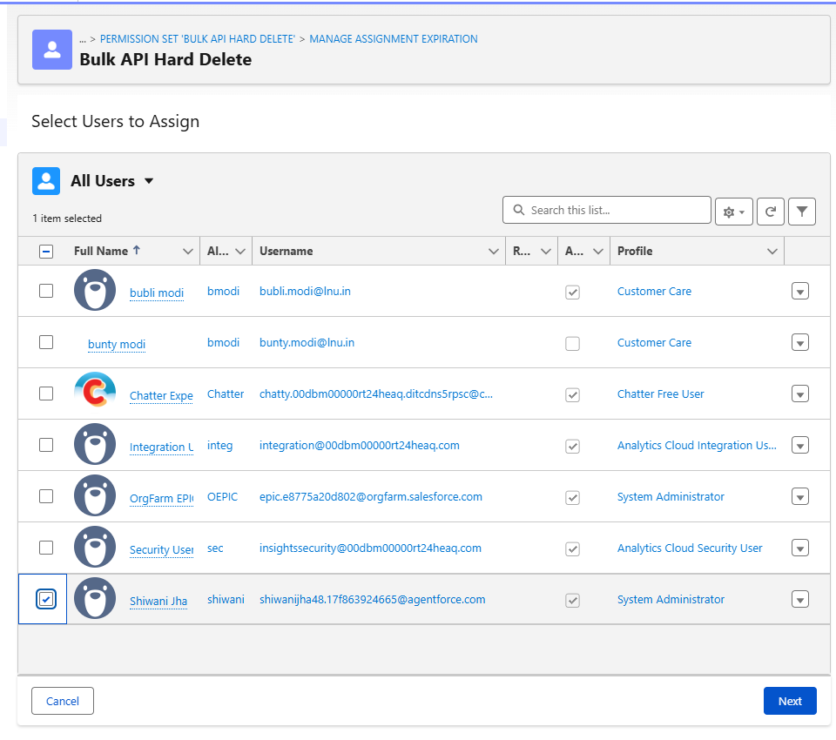
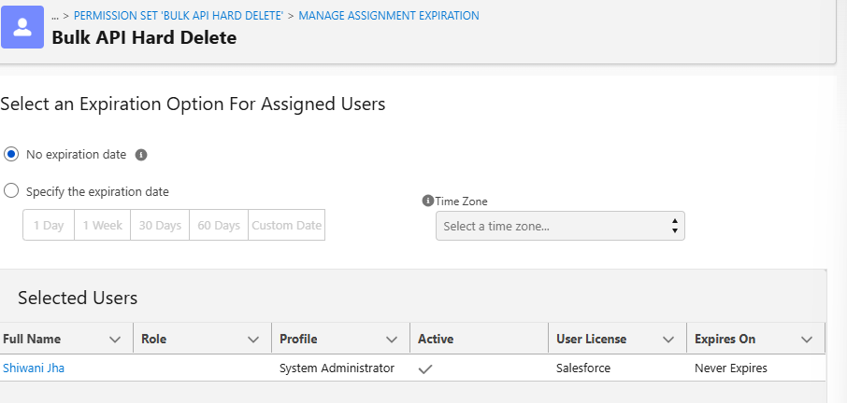
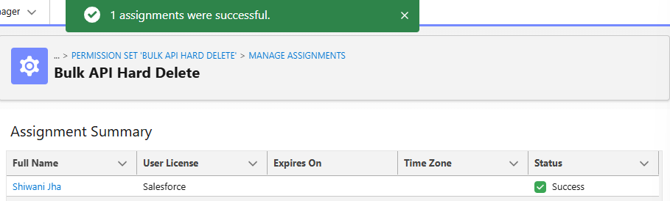
Step 4 — Check Data Loader
Now open Data Loader.
Go to: Settings → Settings
Make sure: Use Bulk API
is selected. Salesforce's current Data Loader documentation says Bulk API must be enabled for hard-delete operations. Then click OK.
Step 5 — Hard Delete
Now you should be able to use:
Data Loader → Hard Delete
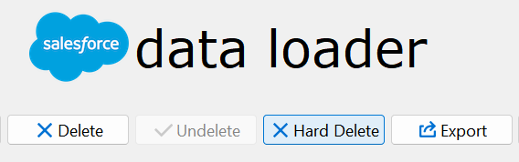

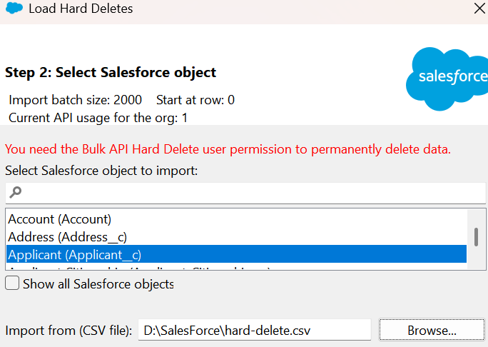
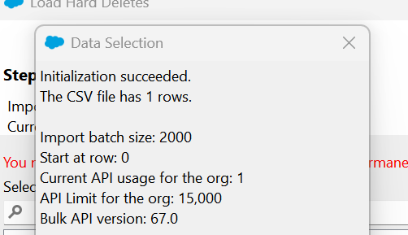
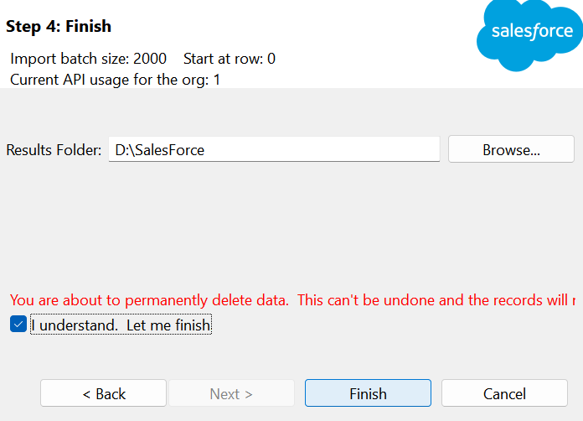

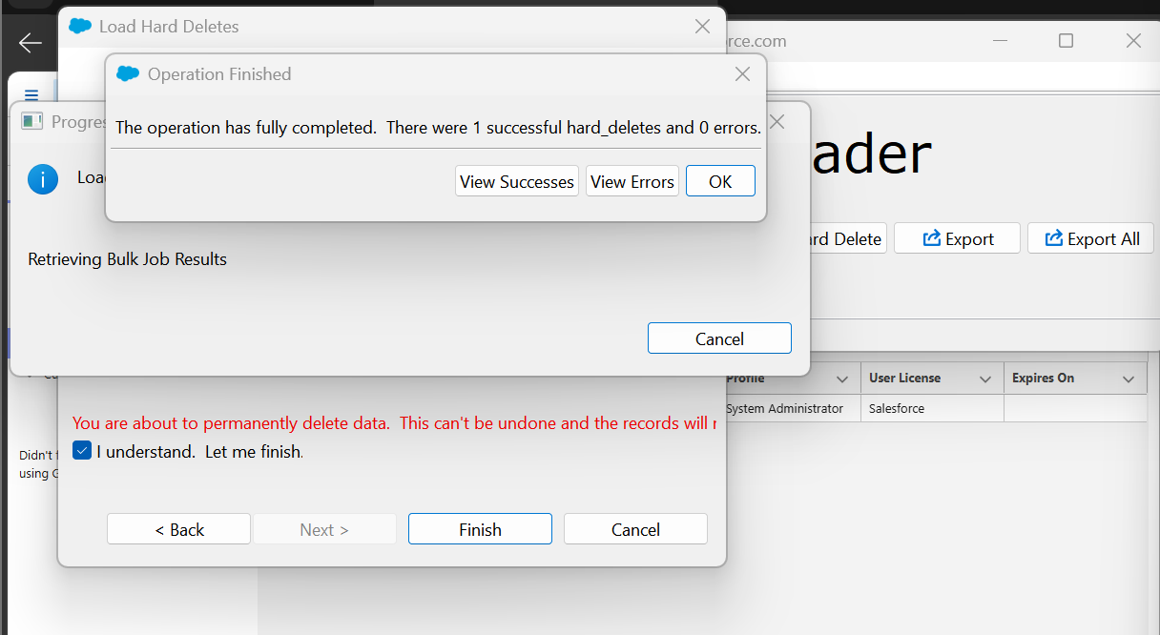
Success file-
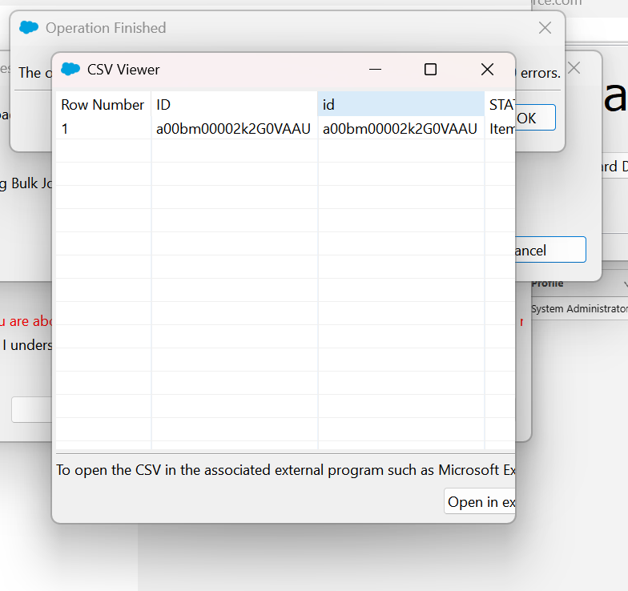
Id – apid-0000000035 is deleted
Before-
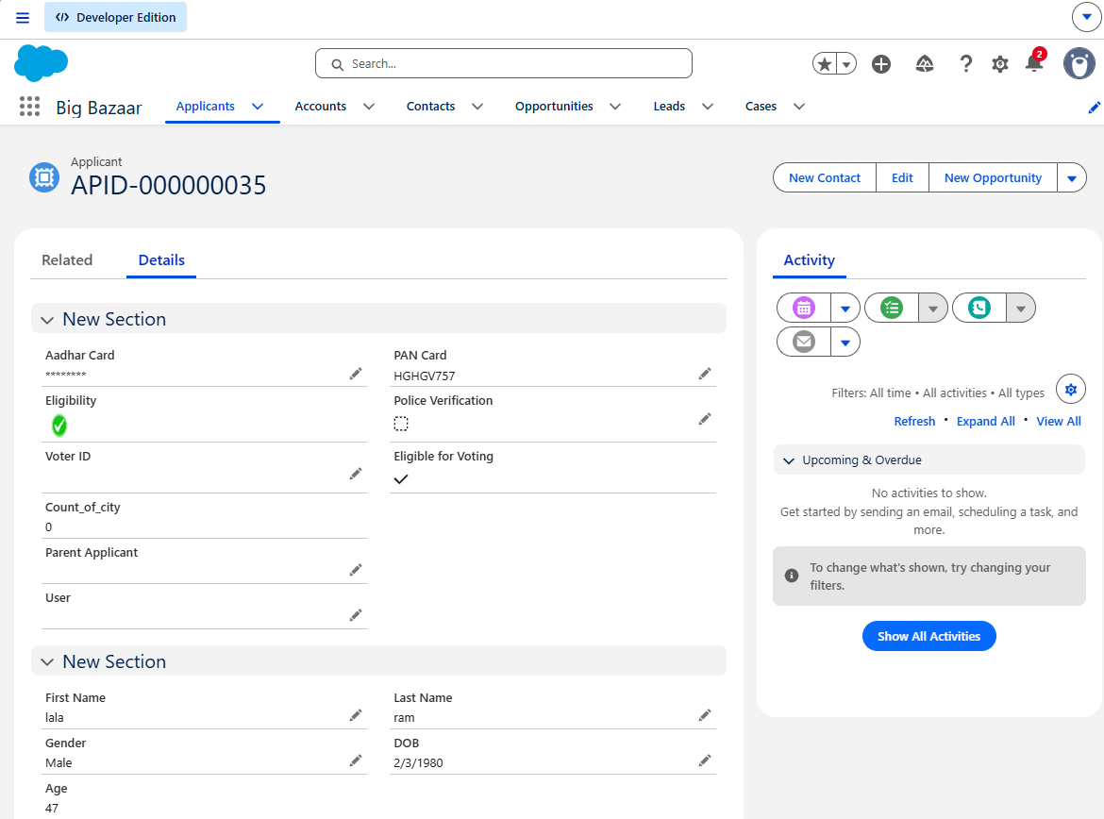
After-
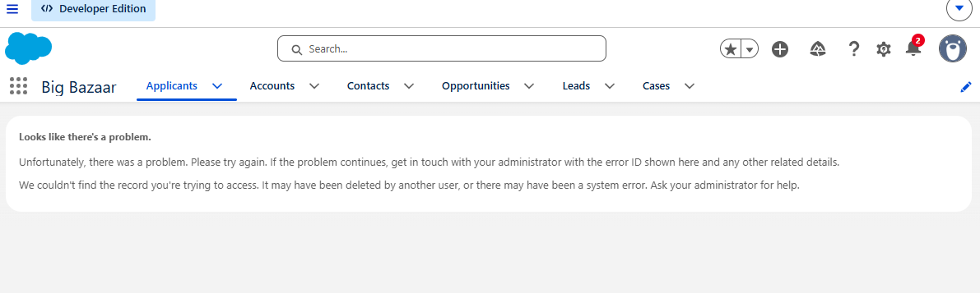

Testing- Verify that the record/file is no longer available after Hard Delete.
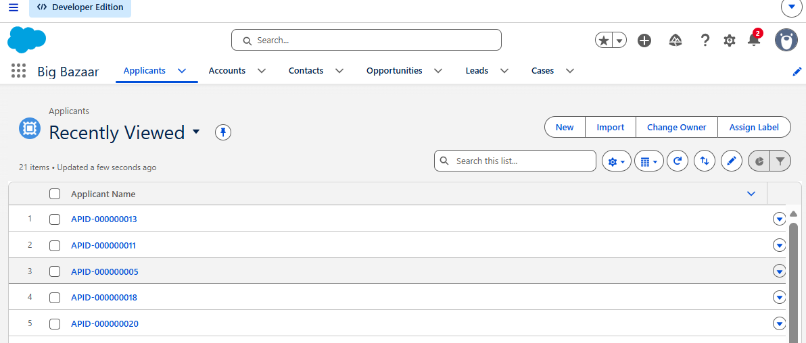
Hard Deleted records are permanently removed and cannot be recovered from the Recycle Bin

Assignment-
Student Data – LNCTU B.Tech 2028
- Prepare an Excel sheet containing student details.
- Fields required: Student Name, Enrollment Number, Gender, Date of Birth, Branch, Course, Age
- Course: LNCTU B.Tech
- Batch/Admission Year: 2028
- Prepare data for 1st Year and 2nd Year students.
- The Excel data can be used for importing student records into Salesforce.

